**BENDING TEST ON MILD STEEL ROD**

Apparatus used:

|  |  |
| --- | --- |
| Universal Testing MachineC:\Users\ATHUL\AppData\Local\Microsoft\Windows\INetCache\Content.Word\Karthik_BMS4.png | Dial Indicators(3Nos.)  Karthik_BMS7  Scale & Vernier calipers |

**STEP:➊** Measure theInitial Diameter of the bending test sample in two perpendicular directions using vernier caliper, calculate the initial area and Moment of Inertia.

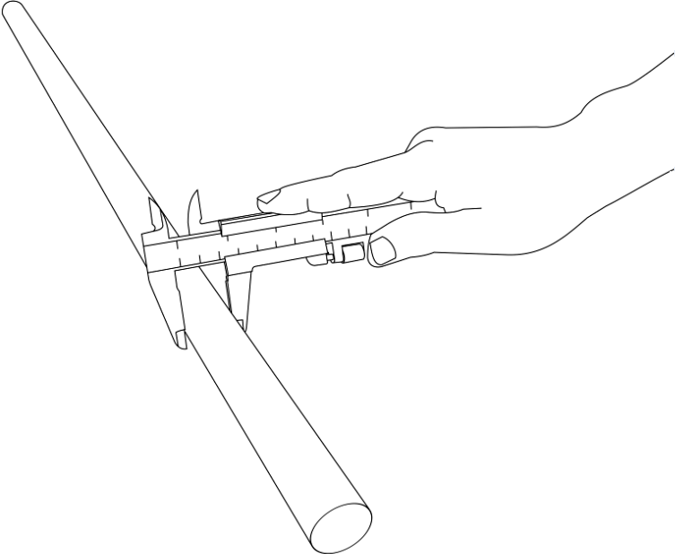

|  |  |  |
| --- | --- | --- |
| Initial Diameter in two perpendicular directions | | Average initial diameter $$d_{i}(mm)$$ |
| $$d_{ix}(mm)$$ | $$d_{iy}(mm)$$ |
| = | = | = |
| = | = | = |

=\_\_\_\_\_mm

,

=\_\_\_\_\_mm

=\_\_\_\_\_mm2

Moment of Inertia about neutral axis for the specimen = = \_\_\_\_\_mm4

**STEP:** **➋** Keeping the span of the beam as **L= 690mm** based on the limitation of the experimental setup and measure the Length of the specimen using scale.

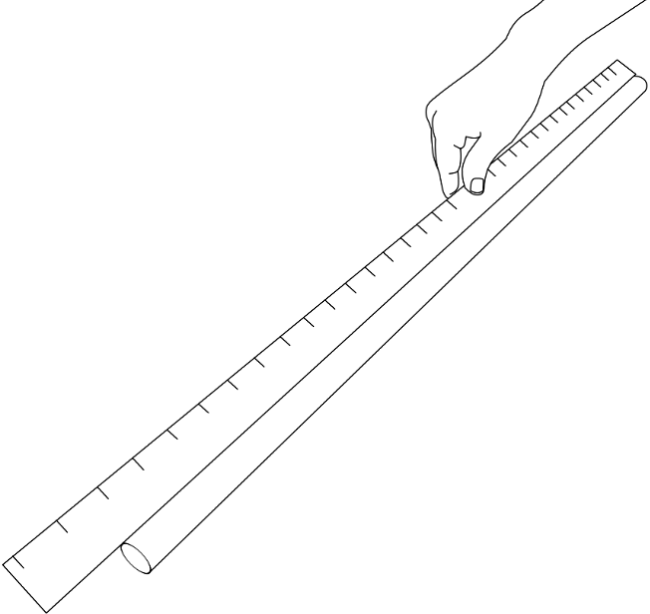

**STEP:** **➌** Based on the span of the beam being **L=690mm** mark on the test sample Mild Steel rod by using a chalk at the mid-span and one-third loading points wherein there will be a dial gauge placed below the each one-third point and the mid-span. The 2 point loading will be applied at the initial and final one-third point.

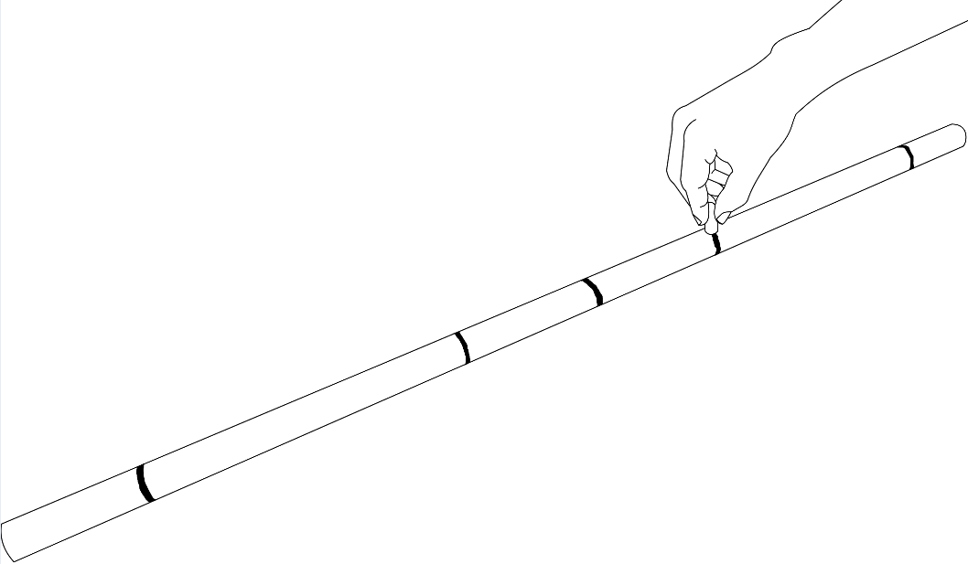

**STEP:** **➍** Insert the specimen between the special 2-Point loading setup and supported on the roller supports which is being fixed on the lower crosshead of the Universal Testing Machine. Adjust all the dial gauges to zero.

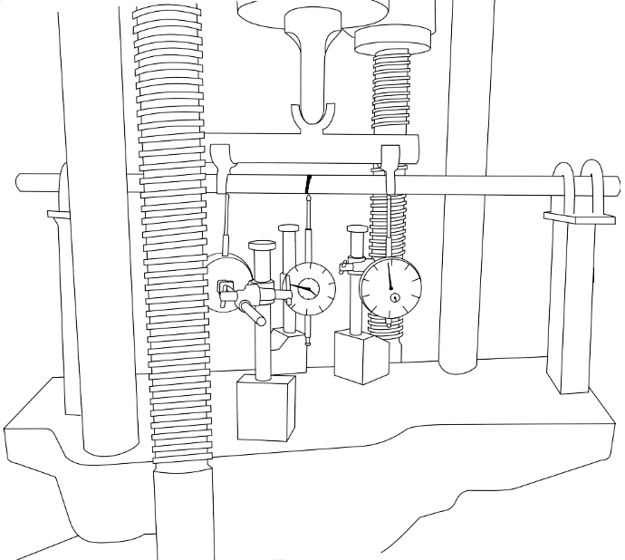

**STEP:** ❺ Start the loading process, note down the deflections using dial gauges under mid-span, one-third span for corresponding load intervals **(Start the simulation)** Stop the experiment after the Mild Steel rod specimen has been yielded.

**STEP:** **➏** Once the yield limit is crossed, the specimen Mild Steel rod will have a permanent bend or deformation as it has crossed the elastic limit.

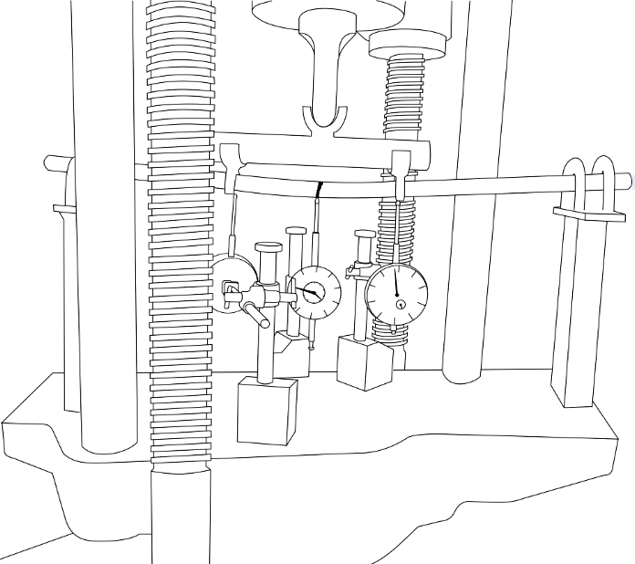

**STEP:** ❼ Plot load vs deformation at mid-span

Slope=\_\_\_\_\_\_ N/mm

Modulus of elasticity== \_\_\_\_\_\_GPa

**STEP:** ❽ Plot theoretical deflection at one-third span vs average experimental deflection at one-third span within elastic limit.

Slope=\_\_\_\_\_\_